AE 210 – Professional Topics

Homework #2

Ben Baker

Submitted March 7, 2024

Title: The Conductor Of Engineers

Response: Fraser describes a great leader as the conductor of the orchestra, not the first violin [1]. A conductor is the leader of the band – they gather the best performers they can and establish a vision – but they also trust and rely on their first chairs and the band [2], [3], [4]. The coach of the First Robotics Competition (FRC) team I was a part of, the Engineers of Tomorrow, Mr. Louis Peters, is someone I consider a great leader; he was able to continuously assemble sub-teams made of and headed by the right people, establish a work culture aimed at the truth, and helped establish our team’s informal Hedgehog Concept.

Collins describes Level 5 leaders as able to both get the right people on the bus and those right people with be self-motivated, with the addition of trust by Fraser [2], [1]. Mr. Peters excelled in finding these right people through the principle of self-motivation and trust; if a specific team member was in the shop consistently on- or off-season helping the team progress he would encourage them through entrusting (informally or otherwise) with specific technical tasks, asking for their input on sub-team projects, or by putting them in charge of a sub-team (that handled the designing, building, and programming & wiring of the robot). As an expansion on Collins’ earlier idea, Elliot further defined that a great leader would inspire a team rather than micromanage [5]. While Mr. Peters would make consistent check-ins with different sub-teams, it was not uncommon for him to let the more self-motivated groups work for a few days to a week at a time while other sub-teams needed assistance (and this ability to leave sub-teams to their own devices can be seen in Fig. 1). This further matches Collins’ Level 5 leader and Elliot’s leader descriptions as through letting the more self-motivated groups work, he avoided de-motivating them [2], [5]. After all, having a leader who micromanages and ignores that what is needed is time to work is both distracting and frustrating.

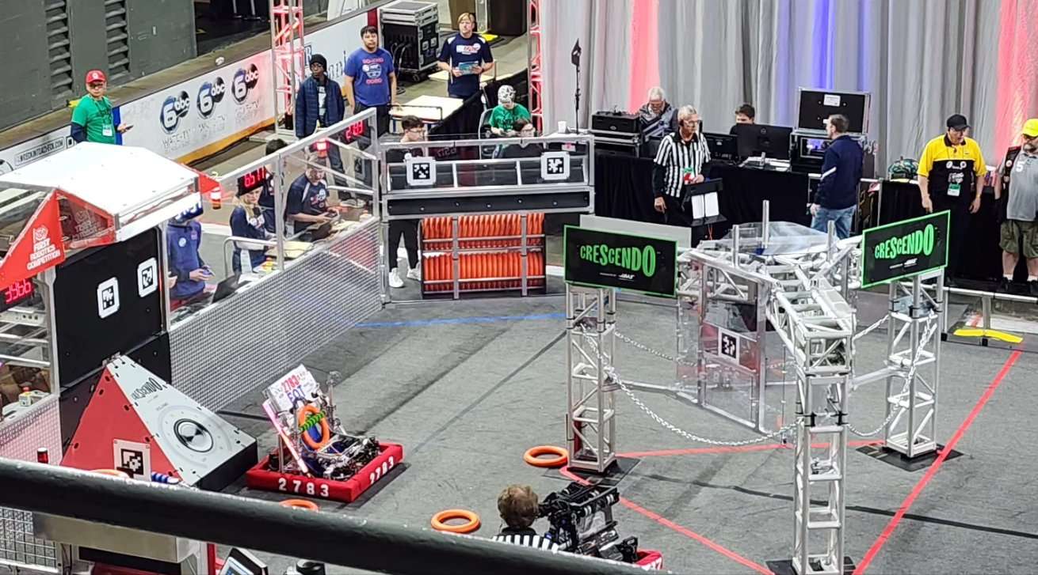

Figure 1. Mr. Peters, topmost center, viewing a 2024 Smokey Mountain Regional practice match [6]

Mr. Peters’ ability for trust also extended to the work environment he helped to facilitate, creating a climate where finding the best solutions – rather than ignoring issues or passing blame – was prioritized; Collins describes creating such a culture as the primary task when taking a company (or in this case, an organization) from good to great [3]. Oftentimes in my own experience leading the Systems sub-team (which was responsible for the programming and wiring of the robot) I would run into issues that I nor the other Systems members could solve, and upon reaching such a point my natural next moves were to first get in contact with a programming mentor from a prior year and then to let Mr. Peters know about the issue. Allowing for the unimpeded involvement of subject matter experts was also another Level 5 characteristic Mr. Peters had in addition to being one of Elliot’s qualities of a leader, as overcoming technical issues comes down to a specific level of understanding Mr. Peters knew he did not have [4], [5]. All in all, I did not feel any pressure to hide the sub-team’s difficulties nor fear consequences for notifying the wider team of them.

Although never officially stated, Mr. Peters was crucial in establishing our team’s Hedgehog Concept of the best “alliance member” [4]. The FRC competitions and matches are based on six teams competing against each other in two alliances to score the most points, with three teams making up an alliance, making teamwork and cooperation crucial to your team’s performance. Rather than solely focusing on creating the most efficient scoring robot, Mr. Peters recognized the larger importance of teamwork and implemented scouting parties of team members that would walk around and evaluate the technical abilities of the other teams’ robots in addition to team members that were assigned to watch matches to pay attention to how effective and efficient each team’s drivers were. Paying attention to the effectiveness and efficiency of the drivers, Mr. Peters was able to steer the team to pay attention more to our and others’ “economic engine,” as Collins described them [4]. Some teams we encountered throughout the seasons had robots that were not complex or lacked some functionality, but more than made up for their deficiencies with driver skill.

Mr. Peters exemplifies Collins’ assertion that leadership begins with getting the right people to confront the brutal facts and act on their implications, rather than just a vision [3]. He was able to find and encourage the right people into their best positions within the team, entrusting them with either roles to advise, oversee projects, or lead sub-teams; he was able to create an environment where issues or setbacks were something to be solved rather than hidden, and acknowledged his own weaknesses in some technical aspects – allowing and often encouraging the seeking of more knowledgeable people; he has always strived to make the team the best alliance member we could be, including inspiring us to look towards more than just technical aspects in a potential alliance member. All in all, he was the conductor of our team, a true leader.

References:

1. S. Fraser, Foreign & Commonwealth Office, “What makes a good leader?” in Gov.uk, May 2014. [Online]. Available: <https://www.gov.uk/government/speeches/what-makes-a-good-leader>
2. J. Collins, “First Who … Then What,” in *Good to Great*, 1st ed. New York, NY, USA: HarperCollins, 2001, pp. 60-90. [Online]. Available: <https://archive.org/details/epdf.pub_good-to-great-why-some-companies-make-the-leap-and/mode/2up>
3. J. Collins, “Confront The Brutal Facts (Yet Never Lose Faith),” in *Good to Great*, 1st ed. New York, NY, USA: HarperCollins, 2001, pp. 91-123. [Online]. Available: <https://archive.org/details/epdf.pub_good-to-great-why-some-companies-make-the-leap-and/mode/2up>
4. J. Collins, “Hedgehog Concept (Simplicity Within The Three Circles,” in *Good to Great*, 1st ed. New York, NY, USA: HarperCollins, 2001, pp. 124-160. [Online]. Available: <https://archive.org/details/epdf.pub_good-to-great-why-some-companies-make-the-leap-and/mode/2up>
5. K. Elliot, “Four Important Qualities Of A Good Leader,” in *Forbes*, Oct 2023. [Online]. Available: <https://www.forbes.com/sites/forbescoachescouncil/2023/10/17/four-important-qualities-of-a-good-leader/>
6. KYEOT2783. “Red alliance for the win! Our second practice match! Terrific job, drive team! We are EOT!!” Twitter. Mar. 7, 2024. [Online]. Available: <https://twitter.com/KYEOT2783/status/1764738555773911494/photo/3>